# **Raspberry PI Setup**

For the IoT workshop you will need a Raspberry PI 3 running the latest Raspbian. The desktop environment is not required for the labs themselves but it might help you get around easier. NOOBS will install the Desktop version. Please follow the following procedure

## 1 – Getting NOOBS onto an SD card

If you managed to get the 16GB micro SD card move to step 2. If you couldn't get the SD card with NOOBS preloaded on time follow the instructions in this page:

<https://www.raspberrypi.org/learning/noobs-install/windows/>

This basically means downloading NOOBS_v2_4_2.zip from this url

<https://downloads.raspberrypi.org/NOOBS_latest>

Then unzipping it and dump all content to a 16GB SD card that has been formatted as a single FAT32 primary partition

## 2 - Install Raspbian using NOOBS

All you have to do at this stage is inserting it into the Raspberry PI and booting up

<https://www.raspberrypi.org/learning/noobs-install/worksheet/>

You will see a menu like this

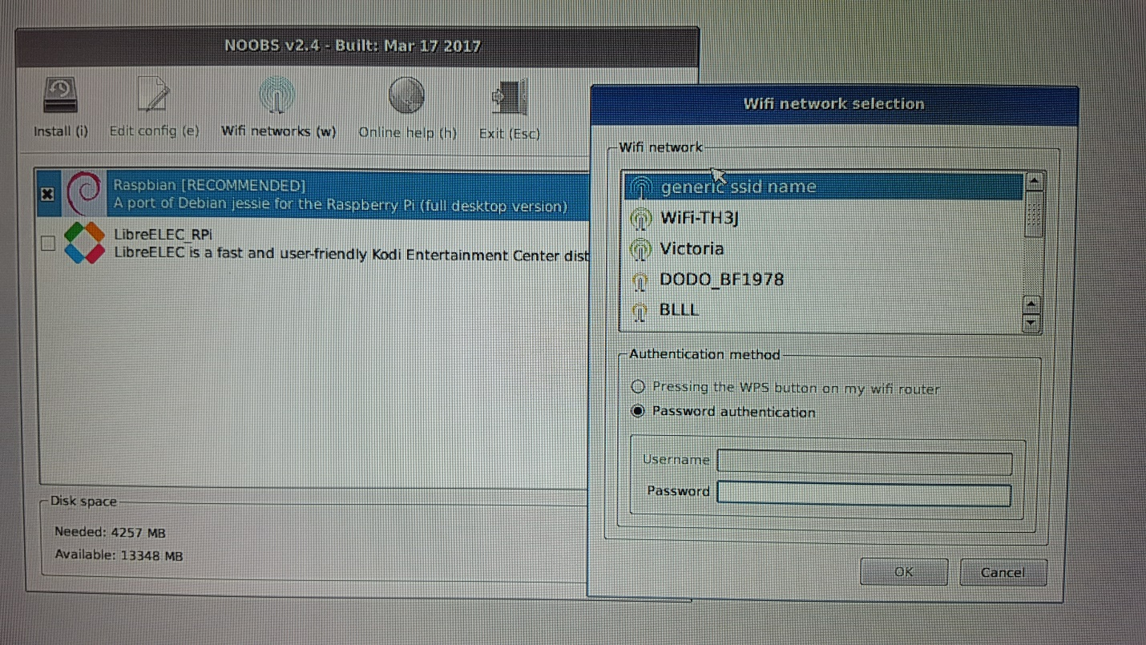

If you provide your WIFI settings it will show you other OS options available. This is nice for future reference, but for the workshop we need Raspbian. Select it and install it

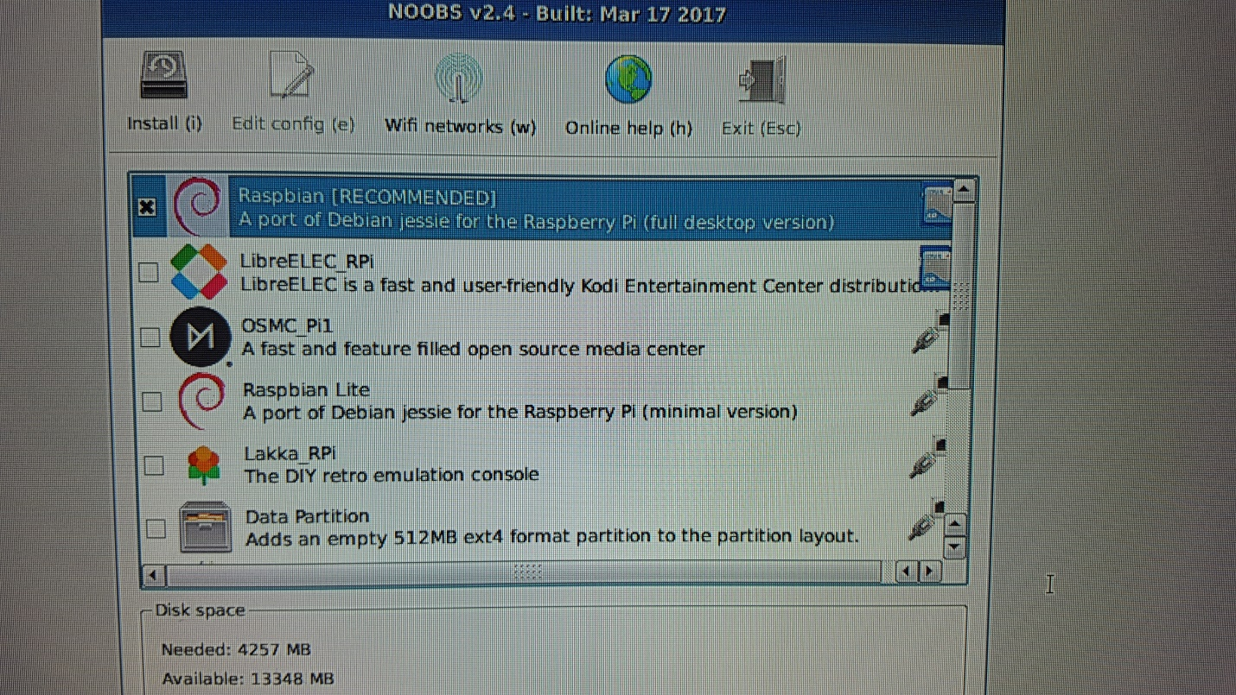

Installation takes about 10 minutes. Once finished it will ask you to reboot at the end

## 3 - Verify you are running Raspbian Jessie

Open a terminal

$ cat /etc/debian_version

8.0

$ cat /etc/os-release

VERSION="8 Jessie"

## 4 - Enable SSH on the Raspberry PI

Launch Raspberry Pi Configuration from the Preferences menu

* Navigate to the Interfaces tab
* Select Enabled next to SSH
* Click OK

From this point you can log on through Putty and use copy and paste

**IMPORTANT**: consider changing the "pi" user default "password" at this stage

## 5 - Verify PIP is installed

It should be installed. If it is not installed then install it

$ pip -V

pip 1.5.6

$ sudo apt-get install python-pip

## 6 – Change the keyboard localisation

It comes by default with UK keyboard and you will need to edit some text files so change it to US

Preferences --> Localisation --> Set Keyboard --> US with euro on 5

## 7 - Verify Flask is installed

It should be installed. If it is not installed then install it

$ pip freeze | grep -i flask

Flask==0.10.1

$ sudo pip install flask

## 8 - Verify GPIO is installed

$ pip freeze | grep GPIO

RPi.GPIO==0.6.3

## 9 - Install mosquitto clients

$ sudo apt-get install mosquitto-clients

## 10 - Install paho-mqtt client for Python

$ sudo pip install paho-mqtt

If it fails with an error about "setuptools" you can try the following. Otherwise skip this:

$ sudo pip install -U setuptools

## 11 - Retrieve Python files needed for the labs

Use WGET to download lab scripts from the RPi. You can run this from the Putty session to the RPi. If WGET is not installed you can install it as well

sudo apt-get -y install wget

wget https://raw.githubusercontent.com/cermegno/iot-rpi/master/basic-flask.py

wget https://raw.githubusercontent.com/cermegno/iot-rpi/master/rpi-pub.py

wget https://raw.githubusercontent.com/cermegno/iot-rpi/master/led1.py

wget https://raw.githubusercontent.com/cermegno/iot-rpi/master/led2.py

wget https://raw.githubusercontent.com/cermegno/iot-rpi/master/photoresistor.py

wget https://raw.githubusercontent.com/cermegno/iot-rpi/master/photo-flask.py

wget https://raw.githubusercontent.com/cermegno/iot-rpi/master/photo-pub.py

## 10 – Setup Tethering

We will need to setup your RPi:

* to use tethering off your phone with a static IP address on your RPi within the range your mobile phone provides while tethering. You will learn how to do this in step 11
* and your laptop will need to use tethering too. Luckily your laptop does have a screen ☺

But, WHY?

* We don't have HDMI monitors in St Leonards to troubleshoot. So you need to know the IP address so that you can ssh from your laptop
* The RPi would likely have trouble connecting to any of our WIFI options in the office

**IMPORTANT:** If this is not done prior to coming to St Leonards you won’t be able to do the IoT labs

In order to select you mobile hotspot use the little antenna symbol at the top right menu. Once you have both the RPi and your laptop connected verify connectivity to the Internet and to your laptop:

$ sudo ping www.google.com

$ sudo ping my_laptop_IP

## 11 - Static IP address

Once everything else is ready you will need to configure a static IP over your tethering

* Make note of your PI network settings, IP, MASK and GATEWAY
* Then edit the “dhcpcd.conf”. You can use the “nano” editor for this if “vi” gives you hassles:

sudo nano /etc/dhcpcd.conf

Then at the very bottom of the file add these the following 4 lines (with your own IP details of course):

interface wlan0

static ip_address=192.168.43.100/24 #####Use your own IP here

static routers=192.168.43.1

static domain_name_servers=192.168.43.1